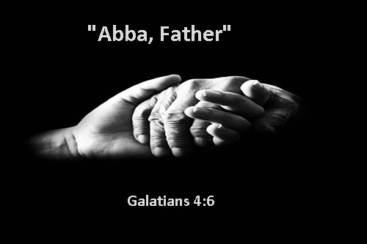

I am thinking of how unworthy I am
These thoughts of sadness nothing new
Dwelling on sin and wrongs I’ve done
Decisions made without You
My life seems so devoid of joy
I wonder what good I’ve truly done?
My life seems to mean nothing
I know it was a life devoid of the Son
I let the world take hold of me
Lead me away from my Father above
It was easier to lead a life of sin
Then to live for His approval and love
My ego allowed me to live for me
To find pleasure in this earth’s domain
Focus on me… not on Him
Yet pleasure seemed to always yield to pain
And then my Father I would cry to You
Please help me; don’t leave me on my own
and ALWAYS I would feel you near
though broken I was never alone
I find it hard to understand Your love for me
I sin daily though I know it causes pain
I am not worthy to be one with You
As I beg for forgiveness again
As my Father your arms are open to me
To accept me covered in sin
You wipe my soul clean with your tears
Though I’ve hurt you again and again
You whisper: this world is not of you
Your worth is not judged by what you’ve done
Your worth my child is in My heart
You are covered by the sacrifice of the Son
Don’t dwell on the dirt of the earthly realm
Focus on Heaven above
And remember you are worthy in My eyes
Of My grace, My forgiveness, My love

Written by TaVona Salaz

